WALT: add a 1 digit number to a 2 digit number
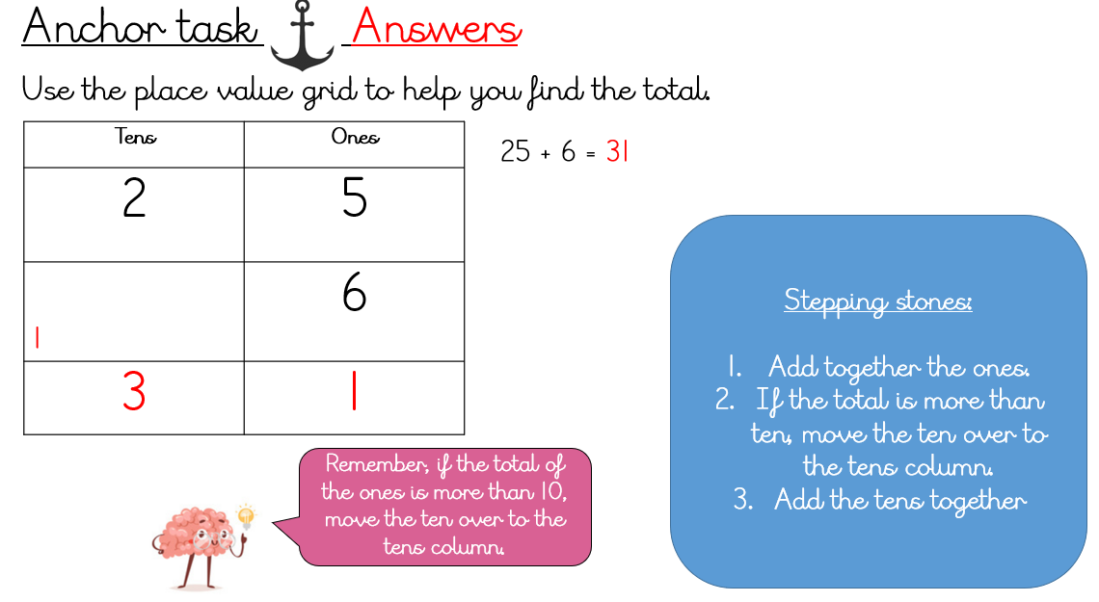
WALT: subtract a 2 digit number from a 2 digit number



